Wrapper classes in Java

The **wrapper class in Java** provides the mechanism *to convert primitive into object and object into primitive*.

**autoboxing** and **unboxing** feature convert primitives into objects and objects into primitives automatically. The automatic conversion of primitive into an object is known as autoboxing and vice-versa unboxing.

## **Use of Wrapper classes in Java**

* **Change the value in Method:** Java supports only call by value. So, if we pass a primitive value, it will not change the original value. But, if we convert the primitive value in an object, it will change the original value.
* **Serialization:** We need to convert the objects into streams to perform the serialization. If we have a primitive value, we can convert it in objects through the wrapper classes.
* **Synchronization:** Java synchronization works with objects in Multithreading.
* **java.util package:** The java.util package provides the utility classes to deal with objects.
* **Collection Framework:** Java collection framework works with objects only. All classes of the collection framework (ArrayList, LinkedList, Vector, HashSet, LinkedHashSet, TreeSet, PriorityQueue, ArrayDeque, etc.) deal with objects only.

The eight classes of the java.lang package are known as wrapper classes in Java. The list of eight wrapper classes are given below:

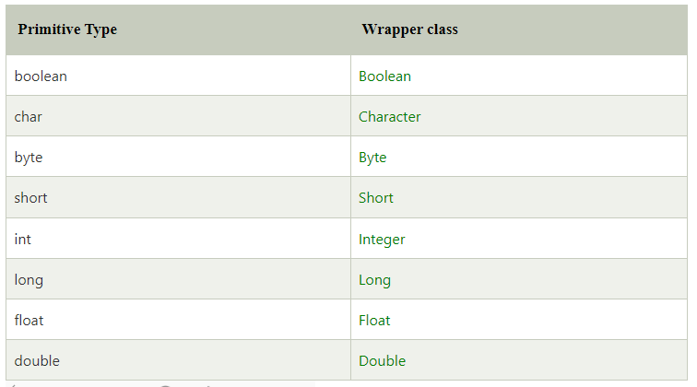

## **Autoboxing**

The automatic conversion of primitive data type into its corresponding wrapper class is known as autoboxing, for example, byte to Byte, char to Character, int to Integer, long to Long, float to Float, boolean to Boolean, double to Double, and short to Short.

We can also use the valueOf() method to convert primitive types into corresponding objects.

### Example 1: Primitive Types to Wrapper Objects

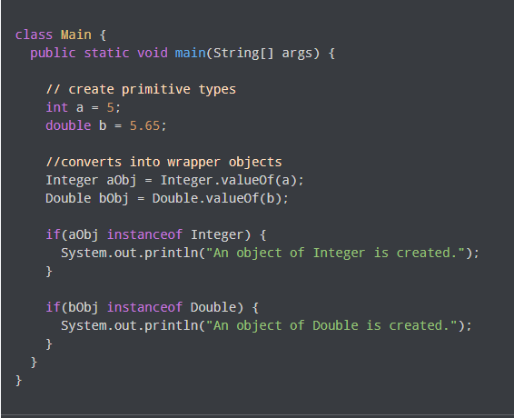

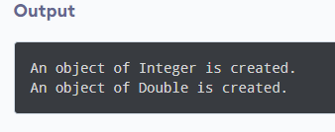

In the above example, we have used the valueOf() method to convert the primitive types into objects.

Here, we have used the instanceof operator to check whether the generated objects are of Integer or Double type or not.

However, the Java compiler can directly convert the primitive types into corresponding objects. For example,

